**Foraging, fear and behavioural traits – a lesson from hummingbirds**

Katarzyna Wojczulanis-Jakubas1, Marcelo Araya-Salas2,3

1Department of Vertebrate Ecology and Zoology, University of Gdansk, Gdansk, Poland; biokwj@univ.gda.pl

2Laboratory of Ornithology, Cornell University, Ithaca, NY, USA. 2Escuela de Biología, Universidad de Costa Rica, San Pedro, San José, Costa Rica

**Abstract**

…

**Introduction**

1. It is now widely accepted that animal’s foraging strategy (i.e. resourse exploitation) depends only on the amount/distribution of available food resources and animal motivation (marginal value theorem) but also predation pressure (Lime and Bednekoff, 1999)
2. The intensity of prey vigilance depends on level of risk and proportion of predator presence. The risk allocation hypothesis (RAH) imposes that prey will allocate the time to foraging inversely proportionately to the predation pressure. The hypothesis usually tested in species that have an obvious predator/s.
3. Hummingbirds are rarely considered typical preys; rather do not have a specialized predator. However, they are often taken oportunistically by a wide range of predators, which imposes a great risk and favor evolution of anti-predator behaviours, including foraging strategy in the conditions of high predation pressure. On the other hand, the hummingbirds, owing to the extremeally high metabolic rate, are very much driven by energy intake. That could constraint evolution of foraging strategy (as a matter of fact, they would be expected to forage regardless of the risk level, so called paradox of RAH).
4. Another question that may affects foraging perfomance is a behavioural profile/personality…. (to be elaborated)

…exploration/risk-avoidance/arousal

**Material and methods**

*Fieldwork.* We carried out the study at the area of one of LBH leks in La Selva Biological Station, Costa Rica (10 o23’ N, 84o10’ W) between May and June 2015. Owing to another project on LBH being carried out the same time, local birds were already individually marked [Fig. 1; foam tags of unique colour combinations, attached to bird back and breast with nontoxic eyelash glue, see Araya-Salas et al. 2018 for details] and habituated to use feeders. Of the XX birds marked at the study lek (XX territorials and XX floaters or females), 12 individuals regularly used feeders utilized in the present study (located at XX distance from the closest lek border) and so were tested in the experiment.

**Fig. 1** Long billed hermit (LBH) marked with a foam tag of unique color-combination. Photo credit: XXXX

We used three one-flower feeders for the experimental set up, arranging them in a line, separated by ca 10 cm distance from each other (Fig. 2). The experiment consisted of two phases – control and experimental, both performed at the same day, with the control being directly followed by the experimental phase. The experimental phase started at the moment when all the focal individuals have been recorded at the feeder for the control conditions, and lasted until all of them visited the feeder again in the experimental conditions. Since focal individuals visited feeders regularly, appearing at the site on average XX times per hour, we were able to complete the two phases within ca XX hours. During both phases of the experiment the three feeders were filled up with ~ 30% sugar-water and birds were allowed to forage on the nectar spontaneously, while their behaviour at feeders site were recorded by human observer and a commercial camera (XX). The only difference between the control and experimental phase were a threat model attached to feeders during the experimental phase. For the threat model, we used specimens of the bull-headed ant (XXX; found dead in the forest). Although the ant is not a predator of hummingbirds (including LBH), the ant-bird encounter imposes potential danger for the bird in the form of being bitten. Indeed, an average birds response was as an expected for a potential treat (see results). We performed total of four complete experimental sessions (control and experiment) within ca two weeks.

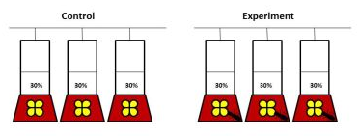

**Fig. 2**. Feeders set up

We first screened video recordings with VLC software (XXXX), to locate and cut out video fragments with foraging visits of all focal birds. As a foraging visit we considered birds’ visit at the feeder area when it inserted the bill into a feeder at least once. For each visit (both at control and experimental phase) we established several crucial time-points (white and black circles on Fig. 3), with 0.1 seconds precision, using Cowlog software. Based on the time-points we calculated duration of events such as: latency to forage (the interval between appearance in the feeder area (usually hovering in front of the feeder) and the onset of foraging, i.e. distance a-b on Fig. 3); foraging interval/s (e.g. distance b-c, Fig. 3; on average XX events); foraging break/s (e.g. distance c-d, Fig. 3; on average XX events); total foraging (distance b-e, Fig. 3) and total foraging visit (distance a-e, Fig. 3). For each visit we also noted which and how many times each of the three feeders were used by the focal bird.

To further analyse birds behaviour we calculated several parameters (see Supplement materials) and selected those which represented the two behavioural traits: exploration and risk-avoidance, and exhibited the highest inter-individual variation. As a proxy for **explorative behaviour** we utilized a **standardized number of feeders** - totalnumber of various feeders (i.e. 1-3 feeders) used during the foraging visit divided by the total foraging duration. As a proxy for **risk-avoidance** we utilized **latency to approach the feeder** – as defined above (latency to forage, distance a-b on Fig. 3). For both the parameters, we assumed that the higher the value, the stronger is the exhibited behaviour.

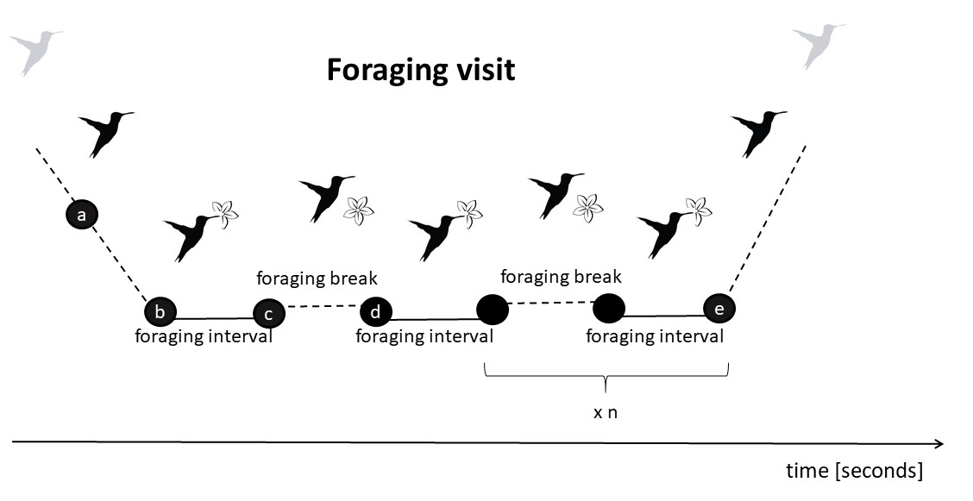

**Fig. 3.** Components of the foraging visit.

As **arousal** we considered a total amount/range of movements at the feeder recorded during the total foraging time (distance b-e on Fig. 3), standardized by the number of feeder changes. For that we first processed the video recordings using Tracker software (XXX), which allowed to establish Cartesian coordinates of a bird position for each video frame. Then, we calculated coefficient of variance of bird movements based on the formula: sqrt((xj - xi)2 + (yj - yi)2), where xi,j and yi,j are Cartesian coordinates of the bird position in a focal i and previous j video frame. Since the birds movements could be biased by explorative behaviour, we standardized this coefficient dividing it by the number of feeder changes at given visit. We expected that the higher value, the higher arousal.

Finally, we calculated **foraging efficiency**, which was the ratio of total duration of foraging (sum of all feeding intervals) and duration of the foraging visit.

*Data analysis.*

**Results**

Foraging efficiency was strongly affected by experimental treatment (LMM, estimate = -0.11, SE = 0.03, t = -3.91, df = 188.17, P < 0.001), in general being lower in experimental conditions (Fig 4A). There were also individual differences in foraging efficiency in response to the treatment (Chisq = 17.06, df = 1, P < 0.001), with some individuals being more efficient in control conditions while others exhibiting a reverse pattern during the experimental treatment; in one case only foraging efficiency was similar in both control and experimental conditions (Fig. 4B).

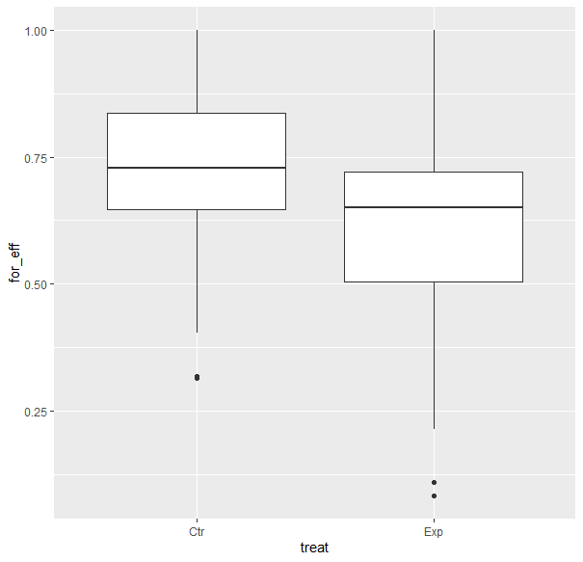

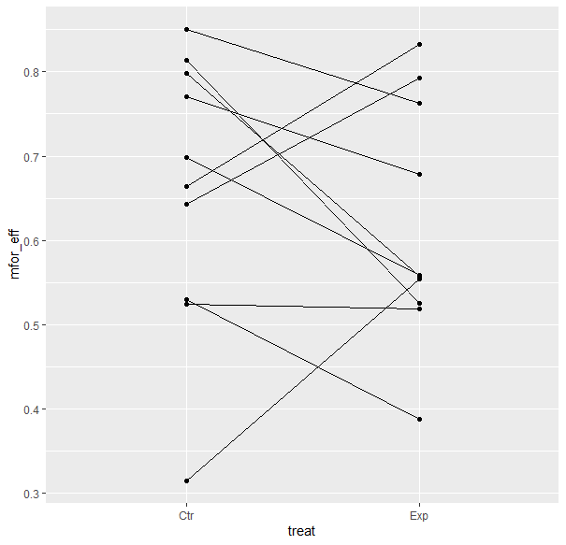

**The explorative behaviour** (i.e. number of feeders used during the foraging visit) slightly increased in response to a threat (LMM, estimate = 0.09, SE = 0.04, t = 2.12, df = 186.57, P < 0.04). The behaviour was related to foraging efficiency (LMM, estimate = 0.47, SE = 0.18, t = 2.53, df = 192.95, p = 0.01), however, direction of the relationship was clearly condition-dependent (as indicated by the treatment x explorative behaviour interaction, LMM, t = -5.72 , df = 188.5, p < 0.001). In undisturbed conditions, the relationship was positive (LMM, estimate = 0.50, SE = 0.16, t = 3.18, df = 139.21, P = 0.002), while in threatening conditions foraging efficiency decreased with exploration index (LMM, estimate = -0.93, SE = 0.21, t = -4.36, df = 49.87, P < 0.001 Fig. 5).

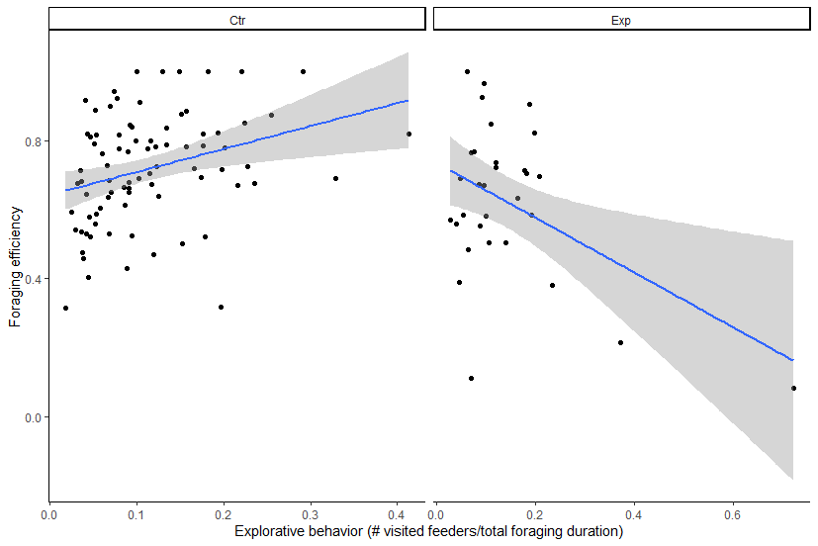

**Fig. 5**

Latency to approach a feeder (**risk-avoidance**) was also affected by experimental treatment, being longer in the threating conditions (LMM, estimate = -0.13, SE = 0.04, t = -3.16, df = 191.329588, P = 0.002; Fig. 6). Overall, and independently on conditions, foraging efficiency was lower when high risk-avoidance was exhibited (LMM, estimate = -0.02, SE = 0.01, t = -2.19 , df = 191.99, P = 0.03; interaction of latency and treatment: estimate = 0.02, SE = 0.01, t = 1.53, df = 191.99, P = 0.13; Fig. 6).

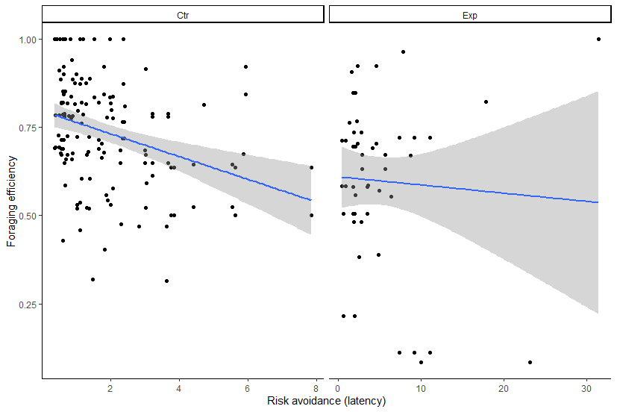

**Fig.6**

The range of birds movements (**arousal**) increased in response to a threat (LMM, estimate = -0.33, SE = 0.05, t = -6.13, df = 188.71, P < 0.001). The arousal was positively related to foraging efficiency (LMM, estimate = 0.04, SE = 0.01, t = 3.85, df = 188.55, P < 0.001), and in the experimental conditions the relationship was the stronger (as indicated by the treatment x explorative behaviour interaction, LMM, t = 5.23, df = 188.36, p < 0.001; Fig. 7).

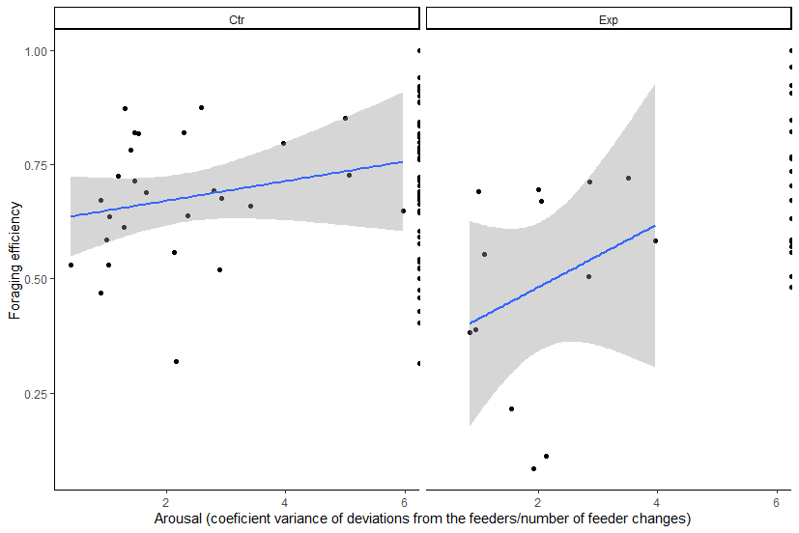

**Fig. 7**

**Discussion**

**Acknowledgments**